Tab 1

Privacy-Preserving AI Workflow with Walrus, Seal, and Nautilus
Sensitive biomedical data (like fMRI brain scans) can be processed with strong privacy guarantees by leveraging the Walrus ecosystem.
—
Walrus provides decentralized, verifiable blob storage for large data; Seal enables client-side encryption with on-chain, programmable access control policies; and Nautilus offers confidential, verifiable computation inside Trusted Execution Environments (TEEs). This design ensures fMRI data is encrypted at the source, stored immutably, and only decrypted within a trusted enclave for AI inference.
The integration addresses compliance (GDPR, HIPAA) and zero-trust requirements by enforcing fine-grained consent, audit trails, and end-to-end encryption.
Walrus acts as the AI data backbone, making stored datasets “trustworthy, provable, monetizable, and secure” .
Seal governs encryption and “programmable access control”, defining “who can decrypt what, for how long, and under which rules” .
Nautilus provides “confidential and verifiable computing” by running AI models inside TEEs that produce cryptographic proof of correct execution . All components are coordinated on-chain (via Sui smart contracts) to enforce policies and log verifiable receipts of data usage

Architecture Overview
The architecture diagram below illustrates how patient data flows through the Walrus ecosystem.

The patient (data owner) encrypts their fMRI scans client-side via Seal’s SDK, which uses a threshold key derived from on-chain policy rules .
The encrypted data is uploaded to the Walrus storage network (decentralized content-addressable nodes with on-chain proofs of availability).

Access policies (consent) are recorded on-chain in a Seal smart contract, ensuring only authorized identities or compute jobs can retrieve decryption keys .

When an authorized AI researcher or service needs to run inference, a Nautilus TEE node (e.g. an enclave in a secure cloud) fetches the encrypted data from Walrus and presents an attestation of its enclave integrity for verification .

Seal’s key servers then release decryption key shares only if the requester’s credentials and enclave attestation satisfy the on-chain policy conditions.
The Nautilus enclave decrypts the fMRI inside its secure memory and runs the AI model, producing results along with a cryptographic proof (attestation) of how the computation was performed.
A Nautilus verification contract on-chain checks the enclave’s proof and records an audit log of the transaction . The researcher receives the AI analysis results, but at no point does any raw sensitive data leave the enclave in plain form. This way, data remains encrypted at rest and in transit, and only exists decrypted within a vetted TEE—fulfilling a zero-trust approach where storage providers, network intermediaries, and even the compute operators cannot access patient data in plaintext .

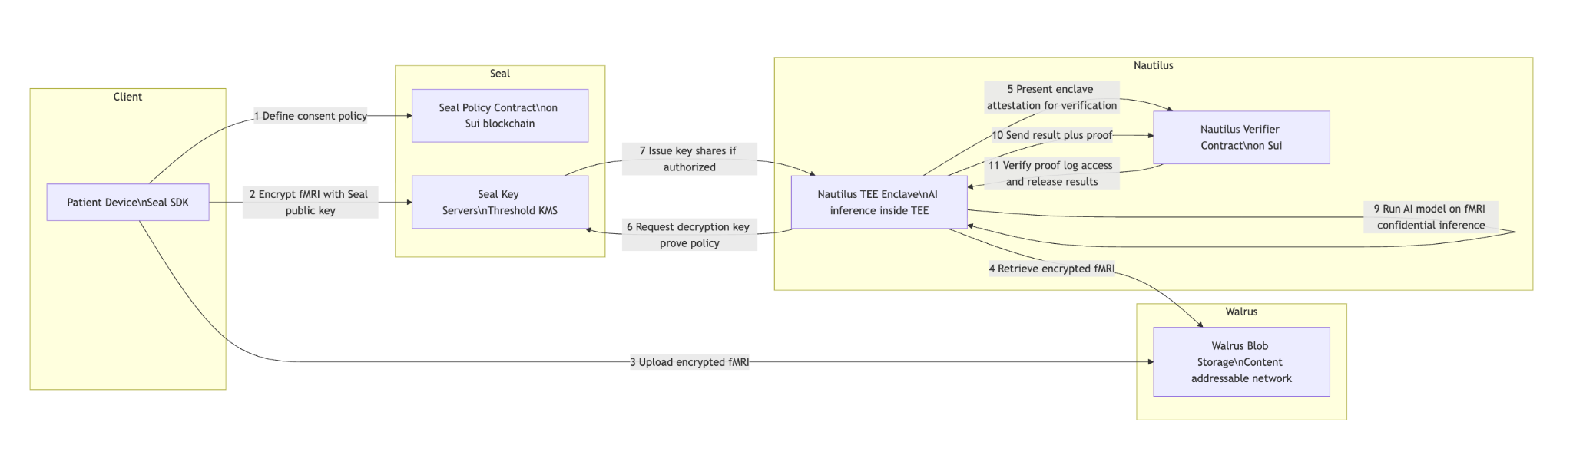High-level architecture integrating Walrus, Seal, and Nautilus for privacy-preserving AI. Sensitive fMRI data is encrypted on the client side (using Seal’s on-chain policy and distributed key management) and stored on Walrus’s decentralized network. When an authorized compute request is made, a Nautilus TEE enclave (with verified identity) fetches the encrypted data, obtains decryption keys from Seal if policy allows, and performs AI inference inside the enclave. The enclave outputs results along with a cryptographic attestation, which a smart contract verifies and logs for audit.

Sequence Diagram: End-to-End Data Flow

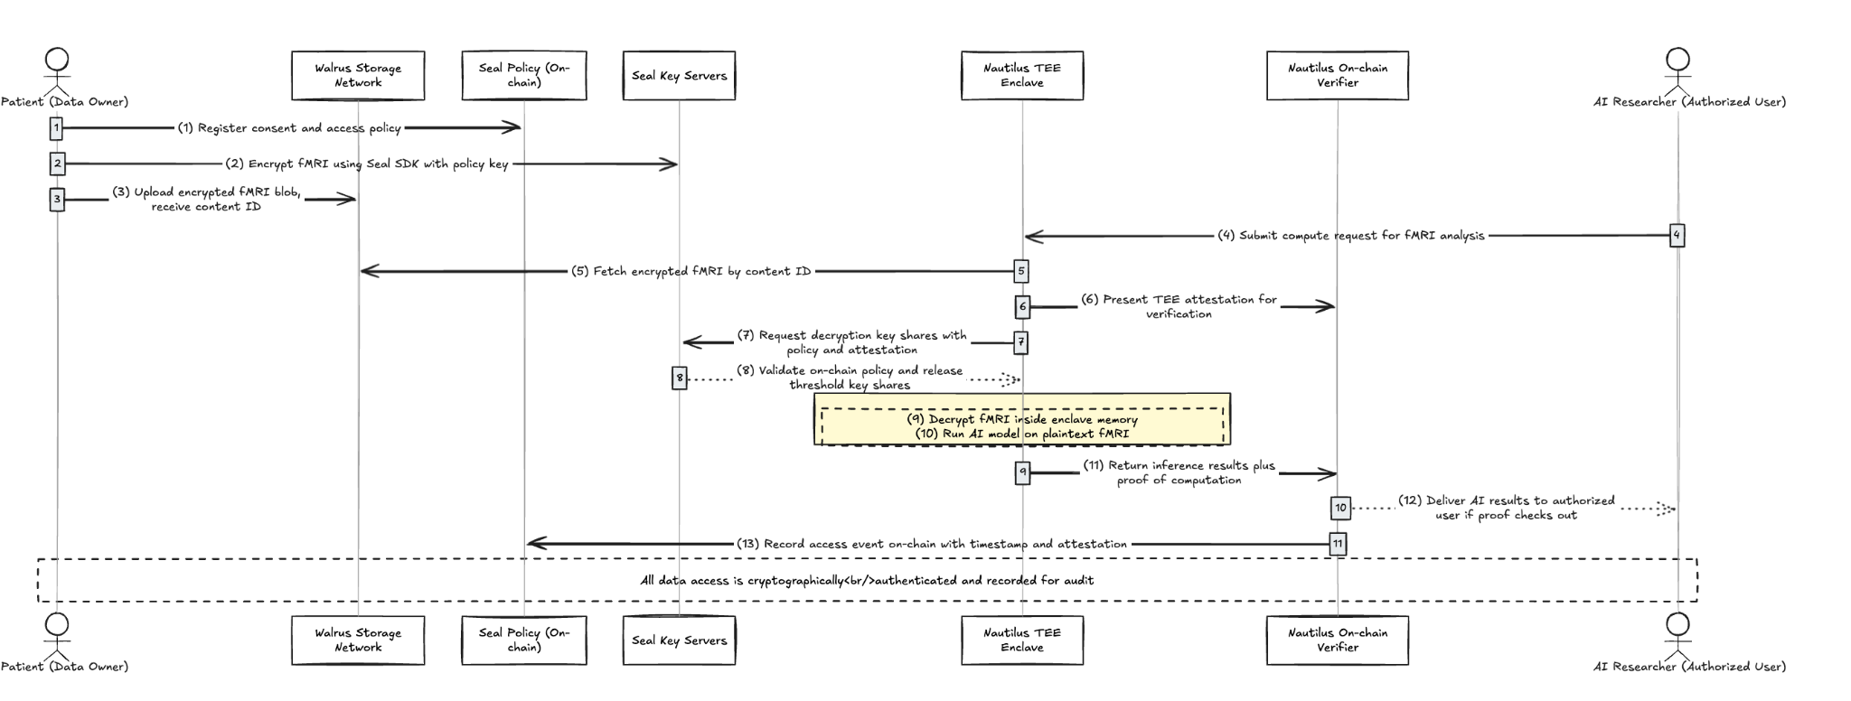
Step 1-3: The patient (or hospital) first defines an access policy on-chain (e.g. specifying which organization or algorithm is allowed to use the brain scan, and under what conditions). Using the Seal SDK, the client then encrypts the fMRI scan with a public encryption key tied to that policy . The data is transformed into an encrypted blob that only authorized parties can decrypt. This encrypted fMRI file is uploaded to Walrus storage, which replicates it across decentralized nodes while registering a content hash and metadata on-chain for verifiability . The patient’s consent and policy are thus immutably recorded, and the raw scan never leaves their device unencrypted.
Step 4-8: An authorized researcher or AI service initiates a computation request (for instance, to run a diagnostic ML model on the fMRI data). The Nautilus enclave (running the AI inference code) is invoked to handle this request. The enclave retrieves the encrypted data from Walrus by its content ID, then attests its identity (using a TEE attestation report) to a Nautilus verification contract on-chain .

This attestation proves the enclave is running approved code in a secure environment (e.g. an AWS Nitro enclave with a known hash) . The enclave then asks Seal’s key server network for the decryption key. Seal’s distributed key servers check the on-chain policy and the enclave’s attestation; only if the requester (and enclave) meet the policy conditions will the servers release their shares of the decryption key . The enclave combines threshold key shares to decrypt the fMRI data entirely within its isolated memory, so the plaintext never appears on any disk or external memory . This enforces a “zero trust” model – neither the storage nodes nor the compute infrastructure can see the sensitive data in the clear .

Compliance, Security, and Collaboration Benefits
This architecture brings technical and compliance advantages crucial for real-world biomedical AI:
- Regulatory Compliance (GDPR/HIPAA): All patient data is encrypted at rest, in transit, and in use, satisfying strict privacy requirements . Fine-grained on-chain policies act as explicit consent records (addressing GDPR’s consent and purpose limitation principles), and no unauthorized access is possible (supporting HIPAA’s Privacy Rule). If needed, access can be revoked or data deleted by the owner at any time – for instance, by invalidating the decryption policy (fulfilling the “right to be forgotten”). The system’s security controls are mapped to standards like HIPAA and GDPR to ensure legal alignment .
- User Consent & Revocability: Patients or data providers remain in control of their data via Seal’s policies. Access is programmatically tied to consent – only computations adhering to the patient’s policy (e.g. specific research study or model) can decrypt the data . Consent can be updated or revoked on-chain, which instantly prevents any new decryption (the Seal key servers will refuse to provide keys if policy is revoked or expired). This user-centric model ensures data usage is always with explicit permission, not just legal agreements.
- Zero-Trust Confidential Compute: The design eliminates the need to trust any single platform or administrator with sensitive fMRI scans. Data is protected through encryption and hardware-backed isolation at every stage. Walrus storage nodes cannot read the data (it’s encrypted client-side), and even the cloud running the AI model cannot see it in plain form because Nautilus enclaves keep it confidential . This mitigates insider threats and external breaches, as even superusers or subpoenas cannot access usable data without the owner’s keys. The combination of Seal and Nautilus essentially extends “zero trust” into the realm of computation – ensuring “encryption at rest, in transit, and in use” inside the AI workload .
- Access Auditability & Provenance: Every data access and computation is logged on the blockchain. The use of Sui as a coordination layer means that whenever the fMRI data is accessed or a model inference is completed, a verifiable record (timestamp, requesting party, enclave proof) is kept . These tamper-proof audit trails enable compliance audits and trustworthy provenance tracking. If an AI-derived diagnosis is questioned, stakeholders can trace exactly which data and model version produced it and verify a cryptographic proof of the process . This level of transparency greatly increases trust in AI outputs, as each result comes with an assurance of how it was obtained (addressing concerns of accountability and reliability in AI-driven decisions).
- Cross-Organization Collaboration: This architecture facilitates secure data sharing and collaboration across hospitals, research labs, and AI developers without exposing raw data. For example, multiple hospitals could contribute encrypted fMRI datasets to a common Walrus repository, and researchers from different institutions can run analyses in Nautilus enclaves on that combined data – without any party ever seeing another’s raw data. The policies can enforce that each collaborator only gets aggregate or relevant results, and cannot extract the underlying data. Such “collaborative data rooms” are made possible where teams “share encrypted data, run computations inside Nautilus enclaves,” and get verifiable results . This approach accelerates research and AI innovation by breaking down data silos, all while preserving privacy and respecting data ownership. It also opens the door for data monetization and marketplaces in healthcare: a hospital could license encrypted datasets (via Walrus) under strict conditions (via Seal), and external AI firms can compute on it in Nautilus with confidence that compliance is enforced and proven. The Walrus ecosystem thus enables new business models around sensitive data by combining verifiable data, programmable access, and trustworthy compute .
In summary, integrating Walrus, Seal, and Nautilus yields a privacy-by-design AI workflow. Patient fMRI data is never exposed in plaintext outside the patient’s device or a secure enclave, satisfying even the most stringent privacy laws. Developers and investors can appreciate that this workflow not only protects individuals but also unlocks valuable cross-organization AI collaborations in a provably secure, auditable, and decentralized manner. The Walrus ecosystem’s unique blend of decentralized storage, on-chain encryption policy, and enclave-based computation provides an unprecedented level of trust in data-driven healthcare applications , making it a compelling foundation for the next generation of compliant AI solutions.

tab 2

Building a Privacy-Preserving AI Pipeline with Walrus, Seal, and Nautilus on Sui Testnet

Prerequisites: Tools, Wallets, SDKs, and Keys
Before diving in, make sure you have the necessary tools and accounts set up:
- Sui CLI and Walrus CLI: Install the Sui command-line interface (for publishing Move contracts and sending transactions) and the Walrus client for data storage. The easiest method is via Mysten Labs’ suiup tool. For example, on a Unix-based system
```
curl -sSfL https://raw.githubusercontent.com/Mystenlabs/suiup/main/install.sh | sh
suiup install sui
suiup install walrus
```
This installs both the sui and walrus CLI tools . Ensure you configure them for Testnet: use the provided Testnet RPC URL for Sui and download the Walrus Testnet config (as described in Walrus docs).
After configuration, you can run sui client active-env to confirm it’s set to testnet and walrus info to confirm you’re pointed at the Testnet network (it should show an epoch duration of 1 day on Testnet) .
Wallet and Keys: The Sui CLI will create a keypair for you during setup. You’ll need a Sui address with some testnet funds. Use the Sui Testnet Faucet to get test SUI tokens (open https://faucet.sui.io, select Testnet, and input your Sui address). Verify you received funds with sui client balance. You will also need Walrus storage tokens (WAL) on Testnet. You can convert some of your test SUI to WAL by running:
This swaps an equal amount of SUI for WAL (1:1 on testnet) . Confirm you have a WAL balance by checking sui client balance (it should list some WAL Token alongside SUI)

We’ll use these in our Seal client configuration. (They correspond to servers run by providers like Studio Mirai, NodeInfra, etc., and are already set up for public use on testnet.)

Seal SDK: Seal provides a TypeScript/JavaScript SDK for encryption and decryption. Ensure you have Node.js installed. You can install the Seal SDK and Sui SDK via npm in your project:
```
npm install @mysten/seal @mysten/sui @mysten/bcs
```
(If you prefer, you can also use the Mysten TypeScript SDK which includes Walrus support , but for our purposes the Seal-specific package is key.) You’ll use this SDK to perform client-side encryption of the data and later to coordinate decryption.

Key Servers: Seal uses a decentralized network of key servers for threshold key management.
On Sui Testnet, there are public key servers available (e.g. by Mysten and partners). For example, Mysten’s docs list testnet key server object IDs like 0x73d05d62c18d9374e3ea529e8e0ed6161da1a141a94d3f76ae3fe4e99356db75 and 0xf5d14a81a982144ae441cd7d64b09027f116a468bd36e7eca494f750591623c8 as available servers .

AWS Account (for Nautilus): If you plan to deploy a real Nautilus enclave, you’ll need an AWS account with permissions to launch EC2 instances and Nitro Enclaves. Install the AWS CLI and have your AWS credentials ready (Access Key ID, Secret, and a default region). This is required because Nautilus currently supports AWS Nitro Enclaves as the TEE (Trusted Execution Environment) platform . If you cannot use AWS, you can simulate the enclave locally (see step 6). Keep in mind an actual TEE provides hardware attestation, which is crucial for full verification.
Development Environment: Ensure you have Rust (for compiling any custom enclave code) and Move (for compiling smart contracts) set up. If you installed Sui CLI via suiup, you already have the Move compiler needed.

Deploying the Seal Access Control Policy (Move Contract)
The first component to set up is a Move smart contract on Sui that defines the access control policy for decryption. This contract will contain a special function (or functions) named seal_approve* which Seal will invoke (in a simulated transaction) to decide whether a given party/request is allowed to decrypt the data . By coding your policy in Move, you get on-chain, tamper-proof enforcement of who can access the secret key.
Write the Move module: Create a new Move package (for example, use sui move new seal_policy to scaffold a package). In the sources/ folder, write a module that includes a policy function. The basic template is:
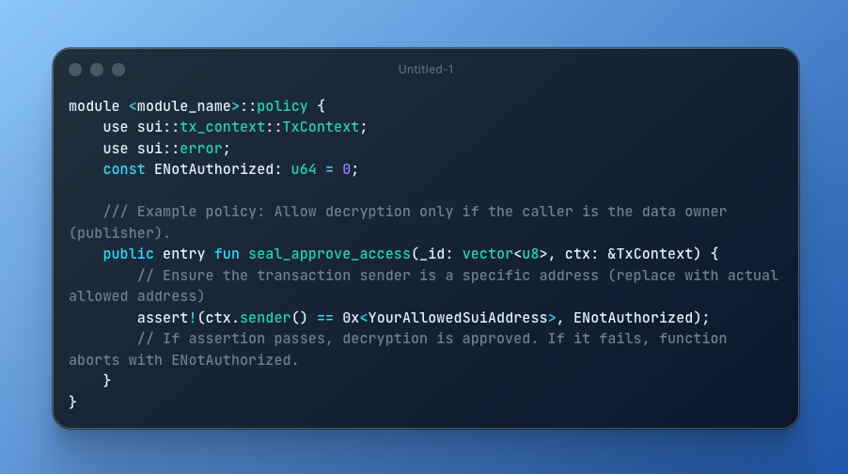
Let’s break down the requirements for Seal’s policy function (as noted in Seal’s guidelines):
- It must be an entry fun (public entry function) .
- Its name should start with the prefix seal_approve. You can append a custom suffix if you like (e.g. seal_approve_access or seal_approve_data), but the prefix is important.
- The first parameter must be of type vector<u8> (this will be the opaque policy ID or “condition ID” passed in by the encryption/decryption process) .
- It returns nothing (if the function executes without aborting, it means “approved”). You implement your access rules via an assert!() or similar check that will abort if conditions are not met

In the above example, we used a simple allow rule: only a specific address can decrypt. Y
ou could make this more sophisticated. For instance, you might pass in an object representing the data or a record of who’s allowed, and assert that ctx.sender() (the caller’s address) matches some field. As another example, the Seal tutorial defines a BottledMessage object with a list of recipients and writes:
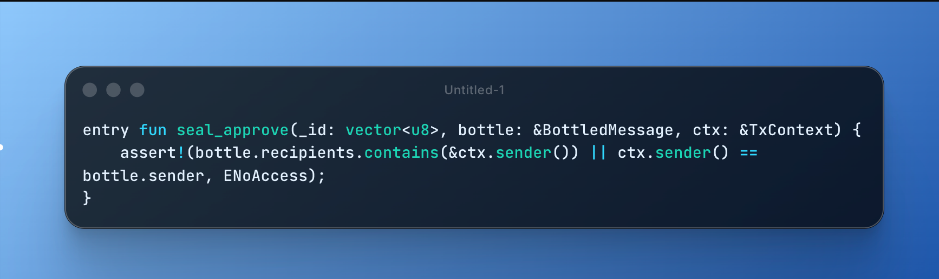

which permits decryption only if the transaction sender is listed as an authorized recipient or is the original sender . You can design your policy similarly to check token ownership, timeouts, etc. (For a hackathon demo, a simple check or even no restriction might suffice – e.g., an “allow-all” policy that simply always passes. In that case, you could just not perform any assert, or assert true so it never aborts. Just ensure you still follow the function signature requirements.)
Compile and publish the contract: Once your Move code is ready, compile it with sui move build. Fix any compilation errors. Then publish the package to the Sui testnet. Use the CLI command (assuming your current directory is the package folder or provide the --path):
Make sure your CLI is set to the testnet environment and you have enough gas (the faucet funds should be plenty). On success, this will output a Package ID (a 0x… hex string) for your deployed package . Note this package ID – it identifies your policy on-chain. We will need it when using the Seal SDK (the SDK must know which contract/package contains the seal_approve logic) .
Tip: You can register your package on the Move Package Registry (MVR) for a human-readable name, but that’s optional. Also, if your policy uses additional Move objects (like the BottledMessage in the example) you’ll have to publish those or include them in the same package. For our simple policy, no extra objects are needed beyond basic checks.
At this stage, we have an on-chain policy ready to enforce decryption rights. Next, we’ll encrypt the data using this policy.

Encrypting Mock fMRI Data Using the Seal SDK
Now we prepare our data and encrypt it so that it’s stored privately (only decryptable if the on-chain policy approves). We’ll simulate fMRI data – for example, a small numerical matrix or image representing brain scan data. It could be a text or CSV file of numbers, or even a small NIfTI image file. For simplicity, let’s assume we have a binary file fmri_data.bin (it can be anything; the content will be encrypted anyway).
Using the Seal SDK in a Node.js script (or in a browser dApp) will allow us to perform client-side encryption. This means the data is encrypted before leaving our environment, using identity-based encryption tied to our Move policy. The encryption process will generate a symmetric data key, split it across the Seal key servers (threshold encryption), and give us an encrypted payload.
Key steps in encryption:
- Initialize the Seal client: You need to connect to Sui and know which key servers to use. For testnet, you can use the known public servers. For example:
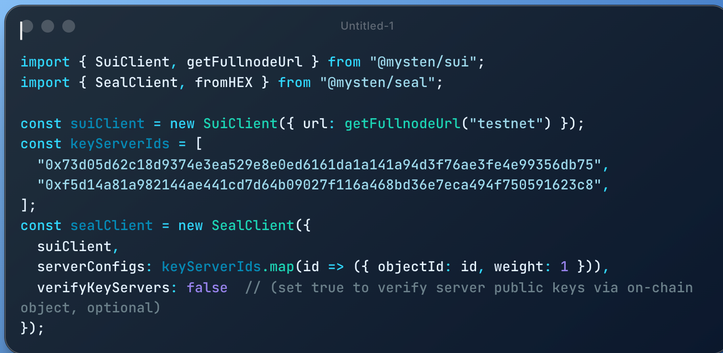
- This configures a Seal client with two key servers, each given weight 1 (meaning both are needed if threshold=2). We disabled verifyKeyServers for performance here (it would double-check that the server URLs match the on-chain records, which you can skip for a quick demo) .
- Encrypt the data: Prepare your data as a Uint8Array (read the file into a buffer). Then call the Seal client’s encrypt method, providing:
  - threshold: The number of key shares required to decrypt. Use 2 if you have two servers (or 1 if using a single server for simplicity).
  - packageId: The ID of the Move package we deployed in step 2 (as a byte array or hex).
  - id: An identifier for the access policy conditions. This id will be passed into your seal_approve function. If your policy doesn’t use this field, you can choose a dummy value. Often this might encode something like a resource ID or a condition; in our simple policy, we could leave it as an empty vector or a constant. (For example, if not used, you could set id = new Uint8Array([]) or some fixed tag.)
  - data: The byte content to encrypt.
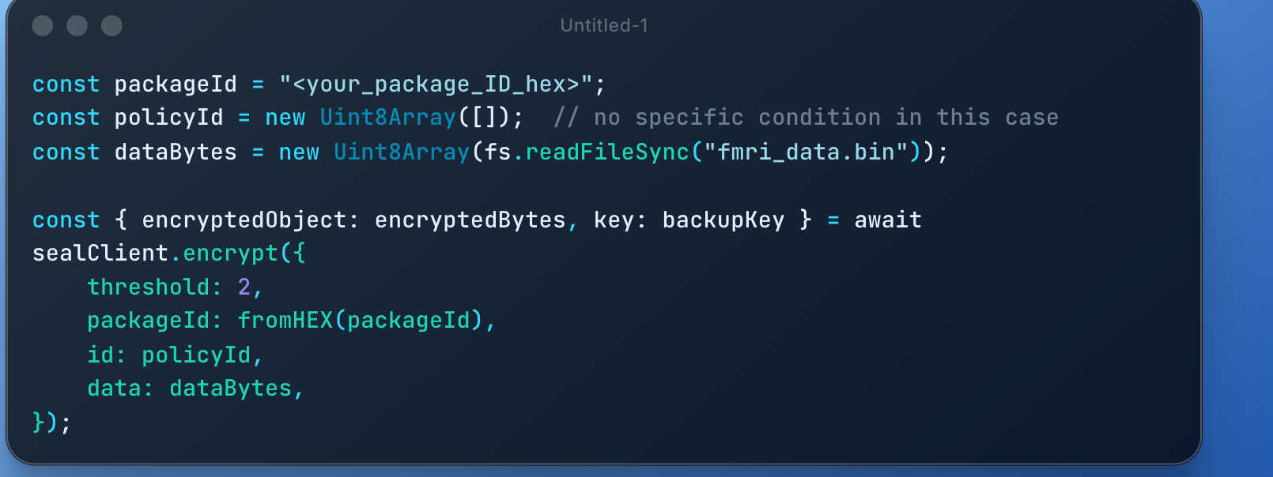
- This returns two things: encryptedBytes – a Uint8Array containing the encrypted blob, and backupKey – the symmetric key used internally (you can hold onto this as a backup or for debugging, but normally you would not share this) . The encryptedBytes includes all information needed for decryption: it contains the ciphertext and the encrypted form of the symmetric key (which the key servers can later reconstruct).
Note: The encryption does not hide the size of the data. So if the size itself is sensitive, consider padding the data before encryption . In our case, since it’s fMRI data, size might not be inherently sensitive, but it’s something to keep in mind.
- Save the encrypted data: Take the encryptedBytes and save them to a file, e.g. encrypted_fmri.bin. This is what we will upload to Walrus. The data is now protected even if someone obtains encrypted_fmri.bin, they cannot decrypt it without going through Seal’s policy (which in turn requires fulfilling your Move contract’s conditions).
At this point, the raw data never left your environment unencrypted. Only the ciphertext will be stored externally. The “key” to decrypt is split among key servers and guarded by the on-chain policy. Next, we’ll store this ciphertext in Walrus for decentralized availability.

Uploading Encrypted Data to Walrus (Testnet)
Walrus is a decentralized storage and data availability layer built on Sui, ideal for storing large blobs like our encrypted fMRI data . We will upload encrypted_fmri.bin to Walrus in testnet mode, so that our enclave can later retrieve it.
Before uploading, ensure you have sufficient WAL tokens (we did that in prerequisites). Walrus charges storage fees in WAL, but on Testnet these are test tokens.
Use the Walrus CLI to store the file as a blob object. For example:
```
walrus store encrypted_fmri.bin --epochs 2 --context testnet
```
This command will upload the file in chunks (Walrus splits files into slivers and distributes them to storage nodes) and register a blob object on Sui . We specify --epochs 2 meaning keep the data for 2 epochs. (On Testnet, an epoch is ~1 day , so this stores the blob for about 2 days. You can always extend or renew storage later, or set a higher number if needed for your demo.)
After running this, the CLI should output a confirmation including the Blob ID (a unique identifier for your blob) or an object ID. For example, it might say the blob is stored and give you an ID like 0xabc...123. You can list your blobs with walrus list-blobs --context testnet to see details (IDs, sizes, expiration) .
Make note of the blob’s ID. The blob ID is essentially a content hash of the encrypted data and serves as a reference to retrieve it. The data is now stored across Walrus storage nodes, and its availability is backed by the Sui blockchain (Walrus uses Sui objects to manage blob metadata and ensure data availability and erasure coding).
Retrieving the blob: If you ever want to download the blob (encrypted) to verify it uploaded correctly, you can use walrus read <BLOB_ID> --out downloaded.bin . This will reconstruct the file from Walrus. However, for our pipeline the enclave will directly fetch or receive this blob, so the user (researcher) doesn’t need to manually download it in practice.
At this stage, we have: an encrypted data blob on Walrus, and a policy on-chain that controls decryption. Now we move to the compute part – requesting a computation on this data.

Creating a Compute Request from a dApp or Researcher
With data in place, a researcher (or any authorized party who wants to run the AI inference) needs to initiate the compute job in the Nautilus enclave. There are a couple of patterns to do this:
- Off-chain Request (Direct): The simplest approach is for the researcher’s app (or a script) to directly call the enclave’s API to start the computation. The Nautilus enclave, as we will set up, runs an HTTP server inside the TEE. We can simply send it a request (e.g. an HTTP POST) containing the necessary input (like the blob ID or the encrypted data itself), and the enclave will process it and eventually return the result.
- On-chain Trigger: A more decentralized approach is to log a request on-chain (for example, by calling a smart contract that records a “compute request” with the blob ID, requester info, etc.). Then a off-chain service or the enclave itself could monitor the blockchain, see the request, and proceed to fetch data and compute. Due to hackathon time constraints, implementing this full event-driven flow might be complex, so we will use the direct approach for now, but keep in mind that an on-chain trigger could be added for a more automated pipeline.
we’ll use the direct invocation method. We assume the enclave’s service will expose a function (endpoint) to handle the compute. The Nautilus template by default exposes POST /process_data for the enclave’s main logic (as seen in the AWS Nitro example) . We will adapt that for our AI use case.
Passing the data to the enclave: We have two choices:
- Send the blob ID and let the enclave fetch the encrypted data from Walrus.
- Send the encrypted data directly in the request.
Option (1) is more elegant (less data transmitted by the user, and the enclave can fetch from Walrus’s network). However, it requires the enclave to include a Walrus client or logic to retrieve the blob via Sui and the storage nodes. Implementing a full Walrus client in the enclave might be non-trivial for a hackathon (it would need networking code to talk to Walrus nodes and assemble the slivers). For simplicity, we’ll choose option (2): send the encrypted bytes directly to the enclave. Since our mock data is presumably moderate in size (and already encrypted, so no privacy issue in transit), this is acceptable for a demo.
So, the researcher will read the the encrypted_fmri.bin (or use the encryptedBytes we got from Seal) and include that in the API call to the enclave. To avoid any binary encoding issues in JSON, it’s convenient to base64-encode the encrypted data and send it as a string in JSON.
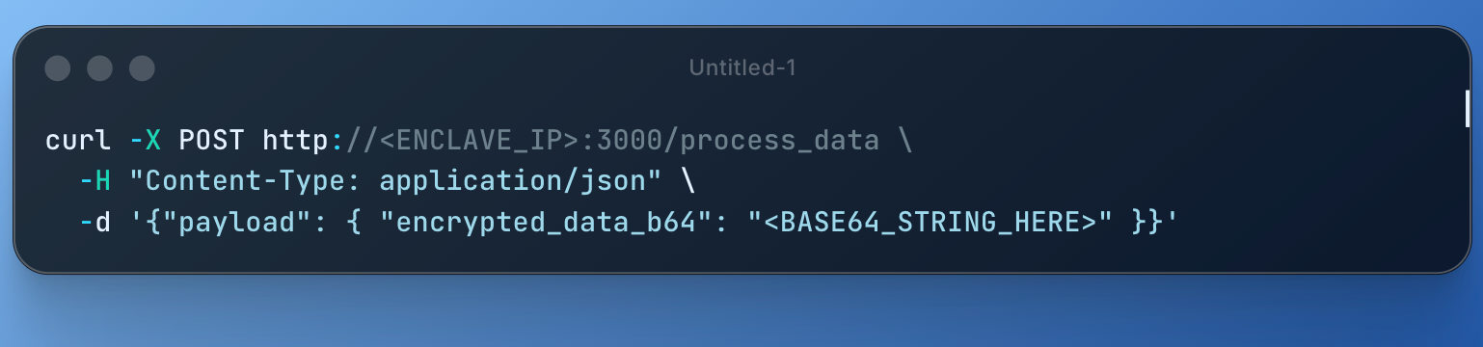In this JSON, we define a field (e.g. encrypted_data_b64) to carry the base64 of our encrypted blob. The enclave’s process_data handler will need to know to read this field, base64-decode it to get the ciphertext bytes, and then proceed with decryption. (We’ll implement that in the enclave code in the next steps.)
If you had chosen to send just the blob ID, the JSON might look like {"payload": {"blob_id": "0x..."} }. Then the enclave would need code to call Walrus. We won’t do that here, but it’s an alternative design.
(Optional) On-chain request design: Just to outline, if we wanted an on-chain trigger, we could have a Move function like request_compute(data_blob: ObjectID) that emits an event or creates a request object. The enclave (or a relayer) would watch the chain (using Sui’s event subscription or polling) for such requests, then act on them. After computing, it would call another contract function to submit the result. This adds complexity and latency but is more decentralized. For a hackathon demo, a direct call is perfectly fine and much easier to implement.
In summary, the researcher/dApp will invoke the Nautilus enclave’s endpoint with the encrypted data. Next, we’ll focus on how to set up and run that enclave.

Launching a Nautilus Enclave (or Simulation)
Nautilus provides a framework to run computations in a TEE (Trusted Execution Environment) and verify them on-chain. The current implementation supports AWS Nitro Enclaves . We will outline how to deploy the enclave on AWS. If you do not have AWS access or want to simulate locally, we’ll mention a fallback for simulation.
Using AWS Nitro Enclaves: The Nautilus team provides a reference template (in Rust) and a setup script to simplify deployment. Here’s the broad process:
- Get the Nautilus template: Clone the Nautilus GitHub repo (MystenLabs’ Nautilus repository) . In this repo, you’ll find:
  - A src/nautilus-server/ directory with Rust code for the enclave server.
  - Example apps (e.g. weather-example under src/nautilus-server/src/apps/).
  - A move/ directory with Move modules for enclave verification (enclave module) and example on-chain logic (weather-example module).
  - Scripts like configure_enclave.sh to automate setup.
- Configure AWS and launch instance: Follow the instructions to set up AWS CLI credentials (export AWS_ACCESS_KEY_ID, etc.) and run the config script. For example:
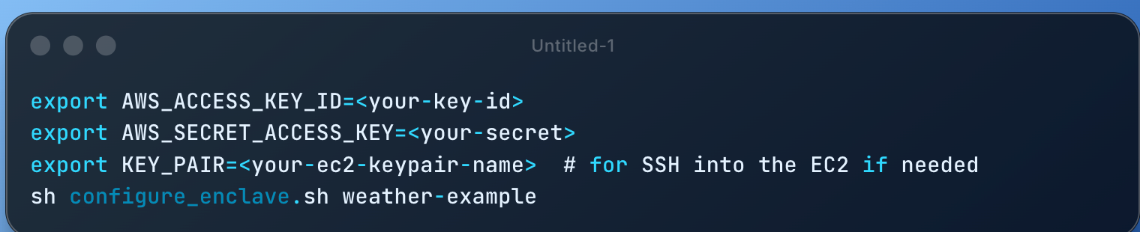
This script will create an EC2 instance (with Nitro Enclave support), prepare the enclave environment, and prompt for some inputs.

In the Nautilus weather example, it asks for a weather API key (via AWS Secrets Manager). For our purposes, if we don’t need external API calls, we might not need a secret. You can respond n when asked about creating a new secret if not needed. The script will output some generated code (like updated PCR values or endpoints) and instruct you to commit those changes . Essentially, it customizes the enclave build for your instance.
Note: If you are in a region other than us-east-1, you might need to set REGION and AMI_ID environment variables before running the script, to pick the correct base image for Nitro Enclaves in your region

Customize the enclave app: We will create our own enclave application logic. E.g., call it ai-example. You can do this by copying the weather-example directory to a new apps/ai-example directory. In that new directory:
  - Edit mod.rs to define the process_data behavior for our AI task.
  - We won’t need to access external internet (unless, say, the model weights are hosted somewhere, but ideally embed any model data in the enclave). So, you can adjust allowed_endpoints.yaml if needed (probably just leave it empty or only include any host you need to fetch from; by default, it might have the weather API domain – remove it if not needed, or add Walrus endpoints if you planned to fetch via HTTP, though Walrus is not trivial to fetch without their protocol).
  - For our use case, process_data should parse the incoming JSON, retrieve the base64 encrypted string, decode it, and then perform the decryption and model inference. We will discuss that logic in the next step. Keep in mind the enclave has an ephemeral key pair it will use to sign responses, and you can use standard Rust crates for cryptography (the Nitro Enclave image supports Rust compiled code, but not an entire Python runtime unless you include it, which is advanced).
- Build and run the enclave: Once your code is ready, compile the enclave and start it. From the project root on your EC2 (which the script set up for you), run:
```
cd nautilus
make ENCLAVE_APP=ai-example && make run
sh expose_enclave.sh
```
This will compile your enclave code into an enclave image file (EIF) and run it inside the Nitro Enclave, then expose port 3000 to the outside world (by punching it out to the parent EC2 and opening it) . If successful, your enclave is now running and listening on port 3000 for requests.
Development Tip: You can run make run-debug instead of make run to run the enclave in debug mode . Debug mode will log verbose output and skip the real attestation (PCR values will be all zeros) . This is useful for testing functionality, but note that the attestation in debug mode is not valid for on-chain verification (since it doesn’t reflect a real secure measurement). For a full demo, you’d ultimately run in production mode to get a real attestation.

7. Verifying TEE Attestation and Requesting the Decryption Key
One of the core innovations in this pipeline is that the blockchain (and the data owner) can verify that the computation is happening in an authentic, untampered TEE before giving it access to secrets. This is where Nautilus and Seal come together.
Verify the enclave attestation: The attestation document obtained via /get_attestation contains a report signed by AWS attesting to the enclave’s identity (measurements) and includes the enclave’s public signing key. We need to verify this on-chain using a Move contract. Typically, the Nautilus Move module (provided in the template under move/enclave/) has logic to parse and verify Nitro attestation. It checks that:
- The attestation is signed by AWS’s root (validating the signature).
- The enclave’s PCR values (which represent the hash of the enclave’s code and configuration) match expected values that the developer trusts.
- Optionally, you might ensure the enclave is running in debug or production as required.
In practice, the Nautilus workflow is: you (the developer) know what the expected PCR values are for your enclave code (the build process can output those). You then publish those expected values in the on-chain contract or use a registration function to store them. The register_enclave (or similar) entry function on-chain would take the attestation document (or its components) as input, verify it, and if valid, record the enclave’s public key in a Sui object (representing an authorized enclave instance) . After this, the on-chain contract “knows” about a valid enclave.
For your hack demo, you have two options:
- Full verification: Use the Nautilus Move contract from the template. Customize it with your enclave’s expected PCR hash (the configure script might have already inserted it in the Move code). Then publish that Move module (as part of your project’s package or separately). Call the registration function with the attestation. This requires formatting the attestation bytes or certificate as function arguments, which can be done via the Sui CLI or a script. On success, the contract would emit an event or store an object indicating the enclave’s public key is registered.
- Simplified approach: If short on time, you might skip strict attestation verification and instead whitelist the enclave by some other means (or even skip this step entirely). For example, your Seal policy could have simply allowed the researcher’s own address (meaning if they control the enclave call, it’s somewhat implicit trust). However, this sacrifices the trust guarantee that it indeed ran in a TEE. For a proper demo, showcasing attestation is compelling, so we recommend at least conceptually doing it.
Let’s assume we follow through with verification. After launching the enclave:
- Use curl <IP>:3000/get_attestation to get the attestation JSON. It includes a field for certificate or report and the enclave public_key. Save this output.
- Invoke the Move contract’s registration function. For example, if the Move module is my_app::enclave with function register, you’d pass the attestation report bytes and the enclave public key bytes. (The Nautilus example uses a specific format for attestation doc – often it’s a signed JSON from Nitro called “DCAP report” or similar. The Move code likely expects certain fields or a concatenated byte blob.)
- Upon calling this, the contract will verify the report and ensure the PCR matches what you set as expected (or what you allow via an update if you gave yourself permission to update expected measurements) . If all checks out, it will store the enclave’s public key on-chain (often in an object mapping instance ID to public key) and mark it as an approved enclave.
From this point on, any output from that enclave can be verified by the contract (because it has the enclave’s pubkey to check signatures). And importantly, you can design your Seal policy to incorporate this attestation knowledge.
How does Seal tie in? Ideally, we want Seal to only release the decryption key to a properly attested enclave. There isn’t yet an out-of-the-box automatic linkage (since Seal’s key servers run the Move seal_approve logic, not an attestation check). However, we can achieve the effect by encoding a rule in the seal_approve function such that only a certain principal (identity) can decrypt. For example, if our enclave has an associated Sui address (the public key hashed as an address), we could require ctx.sender() to equal that address in seal_approve. But who is ctx.sender() in our scenario?
When Seal’s key servers evaluate the seal_approve function, they do so by simulating a transaction signed by a SessionKey (more on this shortly) which is authorized by the user. By default, ctx.sender() will be the user (or an ephemeral session key of the user) trying to decrypt. So the simplest policy was what we did – e.g., allow only the data owner or researcher’s address. That doesn’t inherently guarantee it’s in an enclave.
For a more enclave-centric control, one approach is: the data owner could delegate decryption rights to a specific Sui address that represents the enclave operator. If the enclave is operated by a known party, that party’s Sui address could be the only one allowed to request decryption. This still means the operator (outside enclave) could request the key, so it’s not foolproof. A better scheme (future-looking) is having the enclave itself hold a Sui key and directly request from Seal after attestation, but that’s complex to implement currently.
For our demo, we will assume the researcher (who is working with the enclave) is an authorized decryptor per the policy. In practice, we rely on the fact that the data remains encrypted until inside the enclave, and the researcher only ever sees the final result, not the raw data.
Requesting the key from Seal: Now comes the decryption step. The enclave has the encrypted bytes, but needs the symmetric key to decrypt them. The key is obtained by asking the Seal key servers, which will only comply if the policy contract approves the request.
Normally, a user uses the Seal SDK’s decrypt function which automates this:
- They create a SessionKey (which is basically an ephemeral keypair and a signature from their wallet proving authorization for a short time) .
- They construct a transaction that calls the appropriate seal_approve function with the right arguments (for example, if our policy was seal_approve_access(vector<u8>, &TxContext), the transaction might simply call seal_approve_access(id) with the id we used).
- They feed that transaction to sealClient.decrypt(...) along with the encrypted data. The SDK sends the tx to the key servers, the servers perform a dry-run on a Sui full node to execute seal_approve (with the session key’s signature as if it were the sender) . If the Move logic doesn’t abort (meaning access is granted), each key server returns its share of the key. The SDK combines the shares to produce the symmetric key and decrypts the data, returning plaintext.
In our pipeline, who does this? Ideally, the enclave should do it, because we want the plaintext only inside the TEE. There is no out-of-the-box Rust SDK for Seal yet, but we can replicate the steps or use an external helper:
- A straightforward hack: perform the decrypt step outside and feed the decrypted symmetric key into the enclave via a secure channel. For example, one could call sealClient.decrypt in the researcher’s environment to get plaintext (since they have access per policy), and then send plaintext into the enclave. However, this exposes the plaintext to the researcher, defeating the privacy goal. We want to avoid that.
- A better approach: let the enclave call the key servers directly. The key servers have REST endpoints (the Seal TS SDK uses them under the hood). The enclave could be coded to perform an HTTP request to each key server’s /v1/decrypt endpoint, supplying the needed info (encrypted object, the policy ID, etc.) along with proof of authorization. But authorization normally is a user signature. We could consider that the enclave’s operator pre-approved this by a signature. This is complex to implement in the hack timeframe.
- Simpler integration: Since we trust the enclave, one pragmatic shortcut is to provision the symmetric key to the enclave through AWS Secrets Manager. In fact, the Nautilus example used AWS Secrets Manager to provide the weather API key to the enclave securely . We could do something similar: after encrypting, we have backupKey (the symmetric key). The data owner could store this key as a secret in AWS and configure the enclave to load it (as an env variable). Then the enclave doesn’t need to contact Seal at all – it already has the key once it’s running. This breaks the on-chain enforcement (it moves trust to AWS and the deployer), but it still keeps data encrypted in Walrus and only decryptable inside the enclave. Given the hack timeline, this might be an acceptable shortcut to demonstrate the rest of the pipeline. If you choose this route, you’d skip coding the Seal key retrieval and instead use the key directly in enclave code. Just note in your presentation that in a real system you’d integrate Seal’s key server calls or some threshold scheme.
For completeness, let’s assume we try to mimic the proper method (but possibly in a manual way):
Manual decrypt via enclave operator: The researcher (or enclave operator script) can do the following just before enclave computation:
- Use the Seal SDK on their machine to get the symmetric key: call sealClient.fetchKeys or sealClient.decrypt with checkShareConsistency: false (since we only want the key, not the full plaintext). Actually, the SDK’s decrypt will directly give plaintext if we provide the encryptedBytes, which isn’t what we want outside. Instead, we could use client.encrypt with an ephemeral approach or store the DEM key separately as mentioned in Seal docs . But a simpler method: since we got backupKey during encryption, we actually already have the symmetric key! We could just use that. However, using it directly bypasses the policy. To not violate the concept, one might pretend we “queried” Seal for it.
- Provide that key to the enclave securely (e.g., via Secrets Manager injection as environment variable or through the input payload if we encrypt it with the enclave’s public key).
To keep things tractable: we will assume the enclave somehow obtains the symmetric key after attestation verification. Whether by contacting key servers or via a pre-shared secret, the result is the same – the enclave now can decrypt the data. In an ideal demo, you’d show that the enclave’s attestation was verified on-chain, then perhaps the data owner used that knowledge to provide the key to the enclave (maybe by calling a special Secrets Manager API after seeing the attestation is valid).
In summary, by the end of this step:
- We trust that the enclave is genuine (attested).
- The policy conditions (like correct user or enclave identity) are satisfied.
- The enclave is now in a position to actually decrypt the fMRI data (either by retrieving the key from Seal or by using a provisioned key).
Next, we implement the core logic: decrypting and running the AI model within the enclave.

8. In-Enclave Decryption and Running the Dummy AI Model
Inside the enclave’s secure environment, we will perform the decryption of the fMRI data and then run a dummy AI inference on it. All of this happens within the TEE (so the plaintext data is never exposed outside).
Here’s what the enclave’s process_data handler should do (in Rust pseudocode):
```
// Pseudocode for process_data in enclave (Rust)
fn process_data(request_body: &[u8]) -> Response {
// 1. Parse JSON input
let input: InputPayload = serde_json::from_slice(request_body).unwrap();
let encrypted_b64 = input.encrypted_data_b64; // the base64 string we sent
// 2. Decode base64 to get encrypted bytes
let encrypted_bytes = base64::decode(encrypted_b64).unwrap();
// 3. Decrypt the encrypted bytes to get plaintext
let plaintext_bytes = decrypt_data(&encrypted_bytes);
// 4. Use or interpret plaintext_bytes as needed (e.g., if it's an image or CSV)
// For our dummy example, let's say it's just numeric data. We could deserialize it.
let result = run_ai_model(&plaintext_bytes);
// 5. Wrap the result in the expected response format and sign it
let signed_response = sign_output(result);
// 6. Return the signed response
Response::new(signed_response)
}
```

Some details to fill in:
- The decrypt_data function will implement the decryption algorithm. Seal’s encryption by default likely uses a symmetric cipher (probably AES-GCM). If we have the symmetric key (say 256-bit key) from either the backupKey or via key server retrieval, we can use a Rust crypto crate (like aes-gcm or ring) to decrypt. The EncryptedObject format from Seal can be parsed to retrieve the nonce and ciphertext. (Seal provides an EncryptedObject.parse() in TS to get metadata . We’d need to mirror that logic or simply use the backup key and know the cipher parameters.)
- If implementing manually: Seal’s scheme might be using IBE (Boneh-Franklin or similar) to encrypt the key, but since we have the key, assume it’s just AES-GCM. The encrypted blob likely contains a header with the encrypted key and the ciphertext. However, for our dummy, since we conveniently have backupKey, we could also choose to just symmetrically encrypt the data with AES separately (the simpler approach: treat backupKey as the key that was used in an AES encryption of the file). In fact, Seal’s KEM/DEM essentially does that under the hood – the DEM part is typically AES.
- So in practice, you could do something like:
```
use aes_gcm::Aes256Gcm; // and Nonce etc.
let key = aes_gcm::Key::from_slice(&symm_key_bytes);
let cipher = Aes256Gcm::new(key);
let nonce = ... ; // extract from encrypted_bytes or use a fixed nonce if that was set
let plaintext_bytes = cipher.decrypt(nonce, &ciphertext_bytes[..]).unwrap();
```
- The specifics depend on how the data was encrypted. If using the Seal SDK end-to-end, you might skip this and use their decrypt, but here we demonstrate conceptually.
- Run the dummy AI model: Now that we have plaintext_bytes representing the fMRI data, we feed it into a model or algorithm. Since this is a hack/demo and we might not have a real model, you can simulate a result. For example, suppose the fMRI data is just a series of numbers; we can compute a simple statistic:
  - Compute the average of all values.
  - Or detect a made-up “pattern” (e.g., threshold the values and count how many exceed a threshold, as if detecting activation in brain regions).
  - If you wanted to be a bit fancy, you could incorporate a tiny pre-trained model. For instance, use a small TensorFlow Lite or ONNX model compiled to run in Rust, or even hard-code a trivial neural network. Given time constraints, a numeric summary is fine.
- Let’s say our dummy model computes a single number (e.g., “anomaly score” or “activation level”). We’ll produce that as the result. If GPT-2 or a CNN was intended, you could just output a placeholder like “Healthy” vs “Not Healthy” classification based on some logic on the data. The key is to have some output that depends on the data (even in a trivial way) to show the pipeline working.
- Sign the output: The enclave’s server has an ephemeral key pair (it was generated at launch; the public part was included in the attestation and registered on-chain). We need to sign the result so that the on-chain contract can verify it indeed came from the enclave. In the Nautilus template, the enclave server already signs the payload it returns on the /process_data endpoint using its private key. In the weather example, the response JSON contains fields like intent, timestamp_ms, data, and likely a signature (perhaps implicitly or as a separate field) . Check the template’s common.rs or how the process_data return is structured. It might automatically attach a signature to the JSON response.
If not automatic, we can manually do it: the enclave has its key pair (say as a global or passed to the handler). We can create a digest of the result data and sign it (e.g., using ECDSA or Ed25519 depending on what key type is used – Nitro enclaves often use an RSA or ECDSA key by default). The public key is known on-chain, so we must use the same algorithm to sign.
For simplicity, you could include the signature as a hex string in the JSON response along with the result. For example:
```
{
"response": {
"result": 42.7,
"signature": "<hex_signature_of_result>"
}
}
```

- The signature should cover the result (and ideally some nonce or timestamp to prevent replay). The Nautilus example includes a timestamp in the signed payload . We can follow that: sign (result || timestamp). The on-chain verifier can then check that signature against the enclave’s pubkey and also ensure the timestamp is within an acceptable range (to prevent someone reusing an old result).
Now the enclave has produced the inference output and signed it. The next step is to get this result (and proof) back to the researcher and the blockchain.

9. Generating the Inference Output and Returning Result + Proof
After the enclave finishes processing, it will send the result back to the requester (the researcher’s client) as the response to the /process_data call. This response includes the inference output plus a proof of authenticity (the enclave’s signature, and implicitly the attestation that was verified earlier).
From the researcher’s perspective, they receive a response JSON from the enclave, for example:
```
{
"response": {
"result": 42.7,
"timestamp_ms": 1744041600000,
"signature": "<sig>"
}
}

```

(Your exact format might differ, but assume it contains what’s needed.) The result here is whatever the model output (42.7 could be some risk score, for instance), and the signature is the enclave’s signature over the data and timestamp.
Now, to close the loop, we want to record this result on-chain in a verifiable way:
- We likely have a Move contract (perhaps the same one from step 7, or a separate one) that can accept the enclave’s output and verify the signature. In the Nautilus example, the on-chain part of the app did this verification and then minted an NFT containing the result . In our case, we can simply emit an event or store the result in an object for the demo.
- The researcher will call this contract function, supplying the result, timestamp, and signature from the enclave response. The contract will look up the enclave’s public key (which was stored during registration) and use it to verify that the signature is valid for the given data. If verification passes, it knows the computation was done by a genuine enclave instance.
For example, if our Move module has a function submit_result(result: u64, timestamp: u64, signature: vector<u8>), inside it would do something like:
```
// Pseudocode in Move
let pubkey_bytes = &EnclaveRegistry::get_pubkey(enclave_id);
// Use Sui framework or Nautilus lib to verify signature
assert!(signature_verify(pubkey_bytes, result || timestamp, signature), "BadSig");
emit Event::Result { result, timestamp, enclave: enclave_id };
```
(Sui’s Move might have a native or library support for signature verify; if not, Mysten’s crypto library could be in use.)
The specific code isn’t as important as the concept: the chain smart contract validates the enclave’s proof. This provides end-to-end trust: the on-chain result is only accepted if produced by the authorized code.
Once verified, the contract can then record the result. For a demo, simply emitting an event might be easiest (which you can show via Sui Explorer or CLI). Or you could create an object InferenceResult { data_id, result, timestamp } and make the researcher the owner, so they can fetch it off-chain later.
Finally, the researcher/dApp front-end can query the blockchain to retrieve the result, confident that it’s correct and came from a private computation on the fMRI data.
To recap the data flow for this step:
- Researcher sends request to enclave with encrypted data.
- Enclave returns signed result.
- Researcher (or an automated script) sends the result+sig to a Sui contract.
- Contract verifies and logs the result on-chain (e.g., in an event or object).
- Researcher can now display/use the result, and anyone auditing can see proof on-chain that the result was derived correctly (signature check) after an attested computation.
This completes the main pipeline: the sensitive fMRI data was kept encrypted at rest (Walrus) and in transit, only decrypted inside a TEE (Nautilus enclave) that had to prove itself via Seal policy and attestation, and the result was posted on-chain with a cryptographic audit trail.

10. Logging an Audit Trail On-Chain (Seal + Verifier)
For compliance and transparency, it’s often important to maintain an audit trail of data access and usage. Our pipeline provides multiple points where logging can occur:
- Seal Policy Enforcement: Every time a decryption is attempted, the seal_approve function runs (via dry-run on a full node). Although this doesn’t automatically produce an on-chain record (since it’s a simulation, not a real transaction), you can design your system to log successful decryptions. For example, your enclave could call a logging Move function after decryption succeeds, or the result-submission in step 9 doubles as a log (since it indicates “data X was decrypted and used at time T”). If you wanted, you could include the data’s policy ID or blob ID in the result event so it’s clear which data was accessed.
- On-chain Result Verification: The transaction that submits the enclave result can emit an event that includes references to the data. For instance, it could log an event { data_id: <ID>, enclave: <pubkey_id>, result: <...> }. This on-chain event is an immutable record that “Enclave X processed Data Y and produced result Z at time T”. This is essentially your audit trail. A data provider could later query the chain to see all such events for their data object to see when it was accessed and by whom (by which enclave, on behalf of which researcher).
- Seal Key Server Logs: In a full Seal deployment, the key servers might keep their own logs of key access requests. However, those are off-chain and controlled by the key server operators. Since Seal is decentralized, you rely on the on-chain policy rather than trusting the operators. So we focus on on-chain logs for auditing.
- Walrus Access Logs: Walrus itself doesn’t log reads on-chain (anyone can fetch a blob if they know its ID, but it’s encrypted). However, if you wanted to track data usage, you could require that enclaves only retrieve data via a certain pattern (for example, the enclave could have to call a Move function to “check out” a blob, which then emits an event). This is beyond current capabilities, but an idea for extended auditing.
In our hackathon scenario, a straightforward audit mechanism is: use the event from the result submission as the log. You might also simply output some console logs in your enclave or client for demonstration, showing each step (e.g., “Decrypt key requested for data X – approved by policy”, “Enclave Y accessed data X”, etc.). But having at least one on-chain evidence (like an event) is powerful because you can point to it and say, “See, the blockchain recorded that this enclave (identified by public key) processed the data at this timestamp.”
Additionally, because the entire pipeline is verifiable:
- The on-chain Seal policy and Nautilus attestation checks mean unauthorized access would fail. If someone tried to cheat (say, call the key servers without the proper session key or with a wrong sender), the key servers would not release the key (they’d get a NoAccessError instead of keys) . You could demonstrate this by attempting a decrypt with a wrong account and showing it fails with an error – proving that the policy works.
- The final transaction won’t be accepted on-chain if the signature doesn’t match the enclave or if someone tries to submit a fake result, because the Move contract will abort on bad signature. This guarantees integrity of results as well .
Summarize the audit trail: In conclusion, we achieve a verifiable audit trail through:
- Policy-controlled decryption (ensuring only approved context can access data),
- TEE attestation verification (ensuring the compute environment is trustworthy),
- On-chain result logging (ensuring the outcome is recorded and linked to the authorized compute).
Anyone can later inspect the chain to see that data was only decrypted inside the enclave and see the final outcomes. The combination of Seal and Nautilus effectively addresses both “who can access the key” and “what code ran on the data”

smart contract

Implementing Move Contracts for Seal Policy, Enclave Verification, and Result Logging
To build the full privacy-preserving pipeline on Sui, you will need three Move smart contract components (which can be combined in one package for convenience):
- A Seal Policy Module – defines the seal_approve* function controlling decryption access.
- An Enclave Attestation Module – verifies the TEE’s attestation and registers the enclave’s public key.
- A Result Verification/Logging Module – verifies the enclave’s signed output and logs or stores the inference result.

